

KH5003CMD- Operating Systems, Security, and Network

Portfolio

Student Name: Youssef Mahmoud Taha
Student ID: 202301274

Task 1
1. Introduction
This report provides a comprehensive analysis of a C++ program designed to simulate a Unix-like shell environment. The program provides a command-line interface that allows users to execute built-in commands, manage environment variables, handle file I/O redirection, and execute external system programs using process management system calls.
2. Detailed Function Analysis
2.1 Save IO:
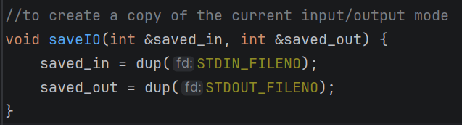
Purpose: This function creates a backup of the current standard input and standard output file descriptors.
Logic:
- It uses the dup() system call, which creates a copy of a file descriptor.
- STDIN_FILENO (0) and STDOUT_FILENO (1) are duplicated and stored in the reference parameters.
Why it's needed: When the shell redirects output to a file, it overrides the terminal's output. This function ensures that the shell can reverse back to normal mode by taking the input from the user and print it normally not in a file.

2.2 Restore IO:
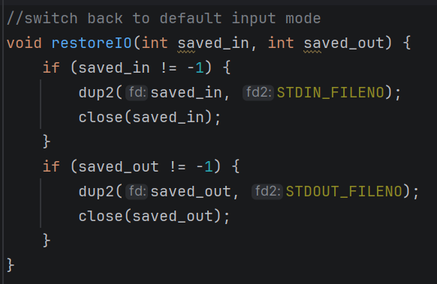
Purpose: This function restores the shell's input and output back to the original state (the terminal).
Logic:
- It uses dup2(), which forces a specific file descriptor to point to the same location as another.
- It redirects saved_in back to STDIN_FILENO and saved_out back to STDOUT_FILENO.
- Finally, it closes the backup descriptors to prevent memory leaks.

2.3 Apply Redirection
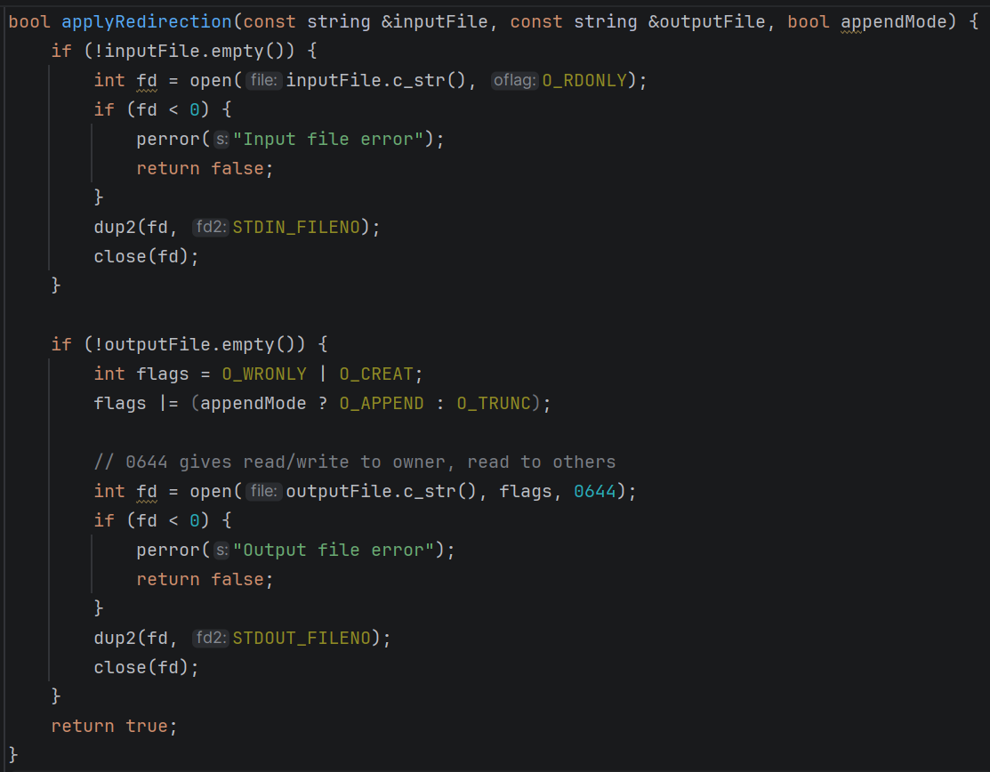
Purpose: This function handles the logic for <, >, and >> operators.
Logic:
- Input Redirection (<): Opens the specified file in read-only mode (O_RDONLY). If successful, it uses dup2 to replace STDIN with the file's descriptor.
- Output Redirection (> and >>): If append Mode is false, it uses O_TRUNC to overwrite the file.
  - If append Mode is true, it uses O_APPEND to add to the end of the file.
  - It uses O_CREAT with permissions 0644 (owner can read/write, others can read) to create the file if it doesn't exist.
- Return: Returns true if redirection was successful, or false (with an error message) if a file could not be opened.
3. The Main Loop and Command Processing
The main function serves as the heart of the shell, operating in a continuous while loop.
3.1 Shell Initialization and Batch Mode
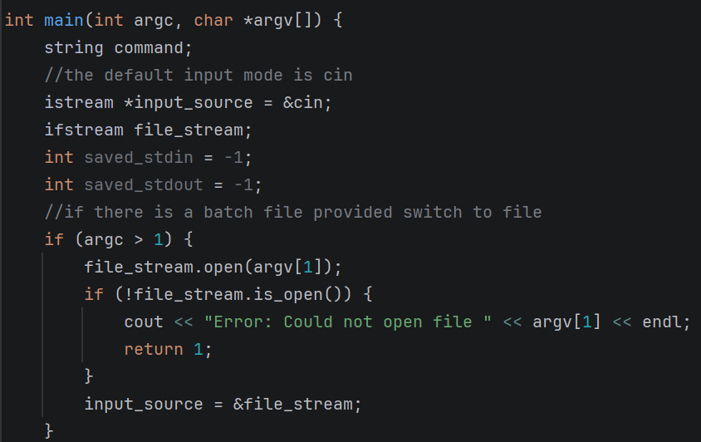
- The shell checks argc. If an argument is provided, it tries to open that file as an ifstream and redirects the input source from cin to the file.
- getcwd(cwd, sizeof(cwd)) is called in every iteration to retrieve the current working directory, which is displayed in the prompt.

3.2 Command Tokenization (Parsing)
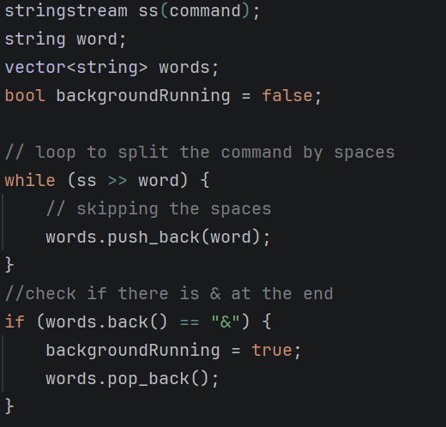
- The shell reads a line using getline().
- It uses stringstream to split the string into a vector of strings named words. This separates the command from its arguments by whitespace.
- It checks for the ampersand symbol at the end of the command. If found, backgroundRunning is set to true, and the ampersand is removed from the arguments.

3.3 Redirection Parsing
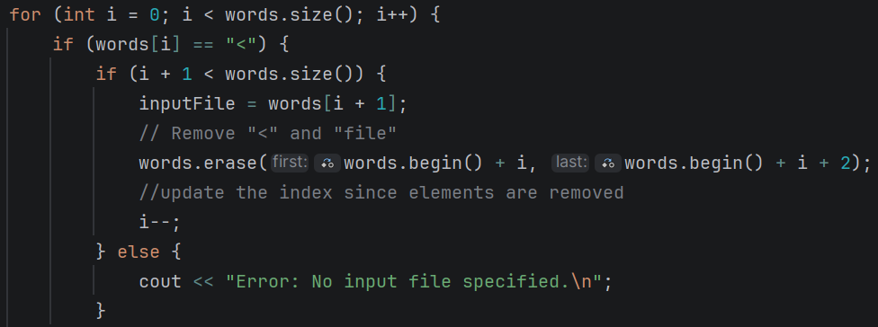
The shell iterates through the tokens to find redirection symbols:
- <: Identifies the next token as the input source.
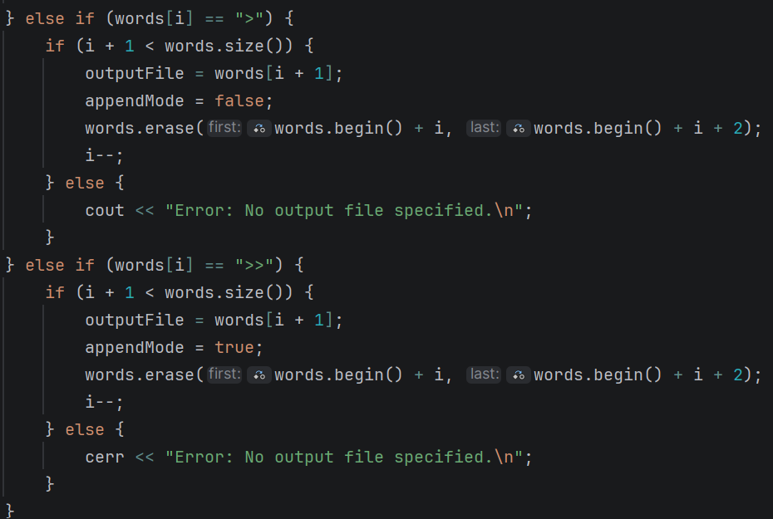
- >: Identifies the next token as the output destination (overwrite).
- >>: Identifies the next token as the output destination (append).
- Once identified, the symbols and filenames are erased from the words vector, so they aren't passed as arguments to the actual command.
3.4 Built-in Command Implementation
The shell manually handles several commands:
- cd:
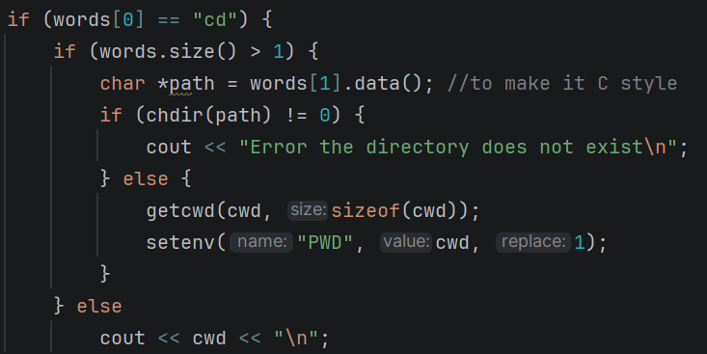
  - Accpets a directory name from the user.
  - Print an error if the directory does not exist.
  - Changes the PWD directory in the using the setenv().

- dir:
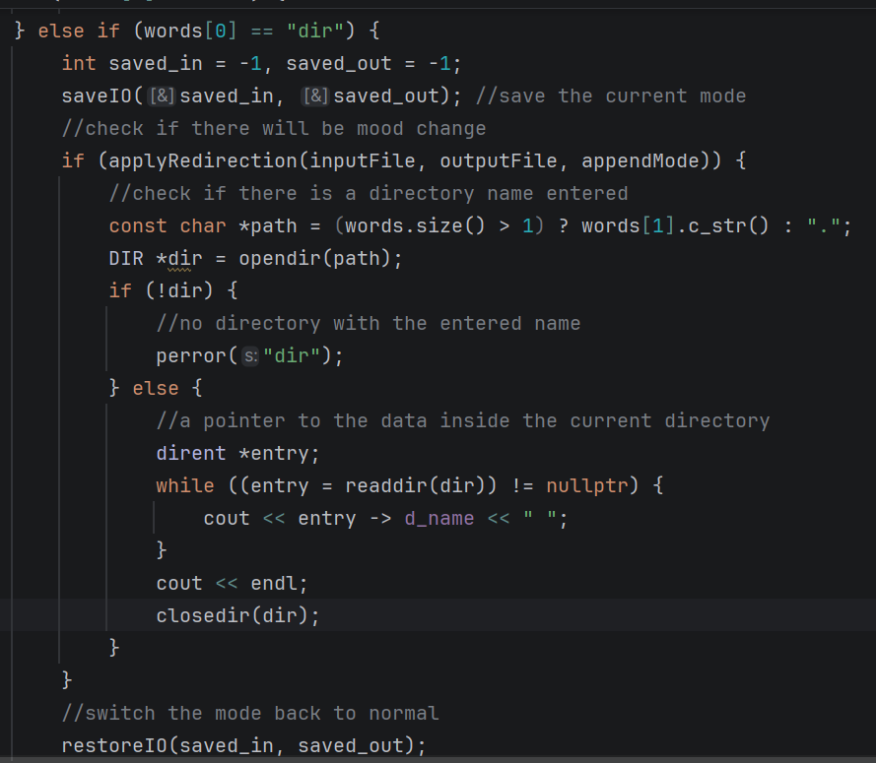
  - Performs a check if the user enters a directory name.
    - If no directory, then the shell opens the current directory.
    - If there is a directory, then the shell tries to open that directory.
  - After the directory is opened, a pointer to the directory content is initialized (dirent).
  - A loop starts to print the directory content.
  - The directory is then closed.

- environ:
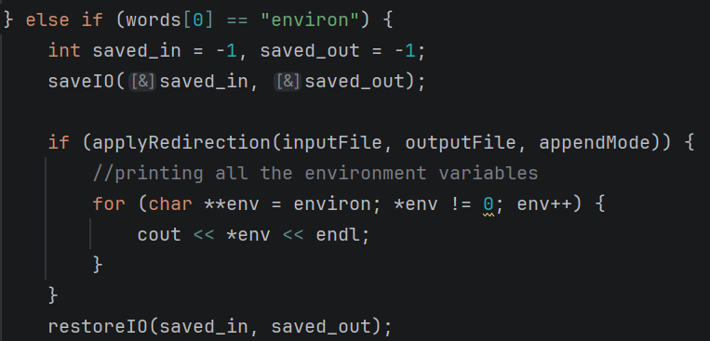
  - A loop is made on all the environment variables from the global pointer.
- set:
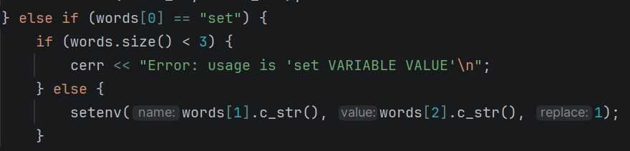
  - using the setenv(), it accepts a variable name and value.
  - The variable data is changed to the value.
  - An error message is shown if there is missing values.

- echo:
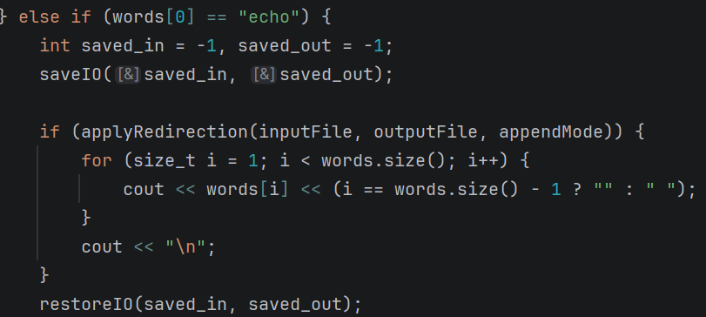
  - Print the entered string in the terminal
- help:
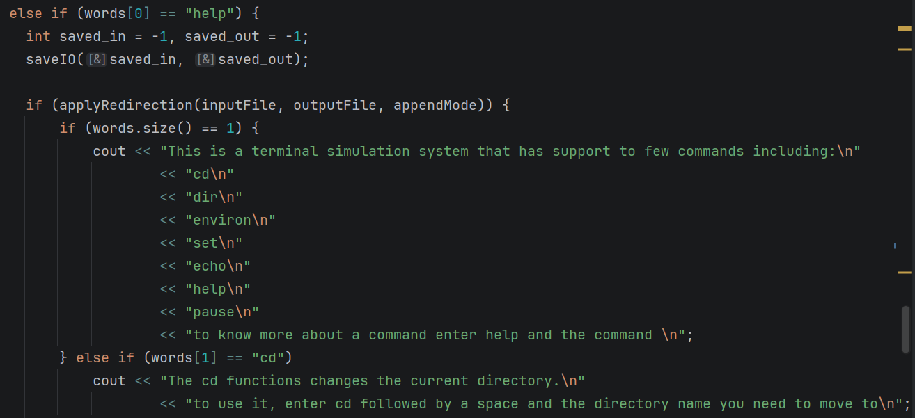
  - Displays a main message explaining the commands handled by the terminal
  - Can accept a string containing the command and the shell will print how to use the command
- pause:
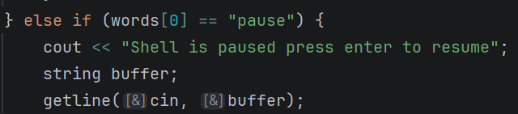
  - Uses getline() to freeze the shell until the user presses enter.
- quit:
  - Breaks the loop to terminate the program.
3.5 External Command Execution (Process Management)
If the command is not a built-in, the shell attempts to run it as an external program:
- fork (): Creates a child process.
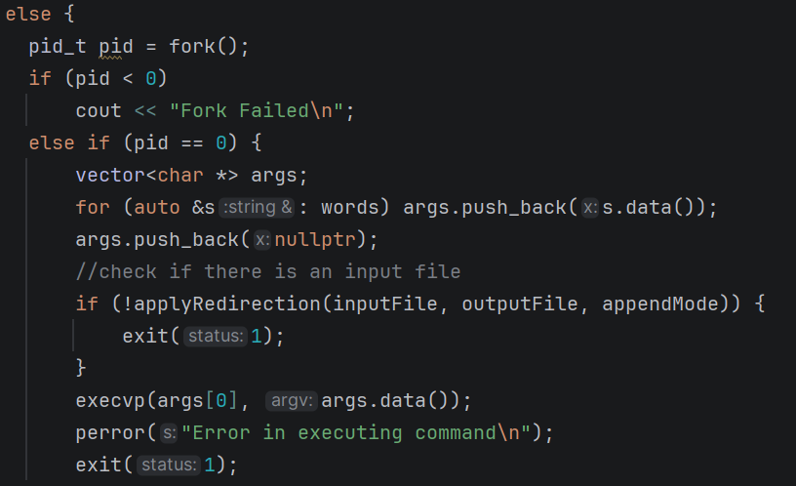

- Child Process (PID == 0):
  - Converts the vector of strings into a C-style array of char*.
  - Applies any requested I/O redirection.
  - Calls execvp(), which searches the system's PATH for the executable and replaces the child process with it.
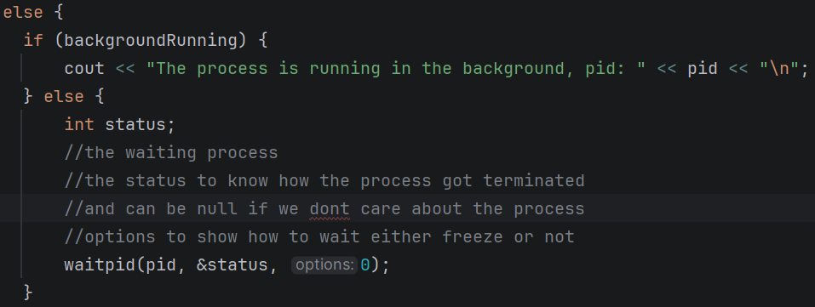
- Parent process:
  - If backgroundRunning is false, it calls waitpid() to wait for the child to finish.
  - If backgroundRunning is true, it prints the child's PID and immediately returns to the prompt, letting the child run asynchronously.

5. Github:
Repo link: https://github.com/youssef1316/OS_coursework1
Commit sha: d37090d

Task 2
1. Introduction
This report outlines the design, implementation, and analysis of a multithreaded C++ program designed to calculate the frequency of words in a given text file. The program leverages POSIX threads to divide the computational workload across multiple cores, improving execution speed for large text files. The program splits the code into chunks of data and processes them in parallel and joins the results safely.
2. Component Analysis
Functions
- Clean: A helper function that sanitizes input by removing non-alphabetic characters and converting all letters to lowercase. This ensures accurate counting.
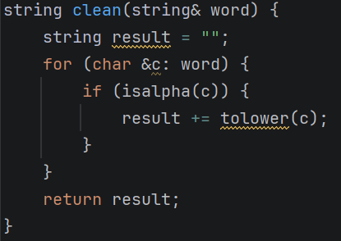

- Count: Executed by all the working threads. It iterates through its assigned lines, utilizes a stringstream to extract individual words, cleans them, and updates its local frequency map. Afterward, it locks the mutex, updates the global map, and unlocks it.
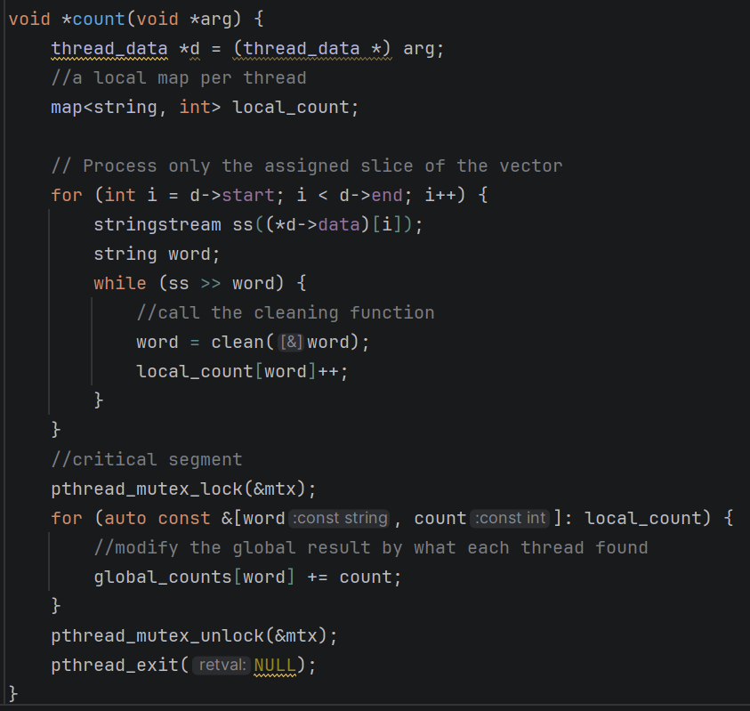

3. Execution Flow
- Initialization: The program validates command-line arguments, extracting the target filename and the optional thread count (defaulting to 4).
- File I/O: The entire file is read sequentially line-by-line into the data vector. 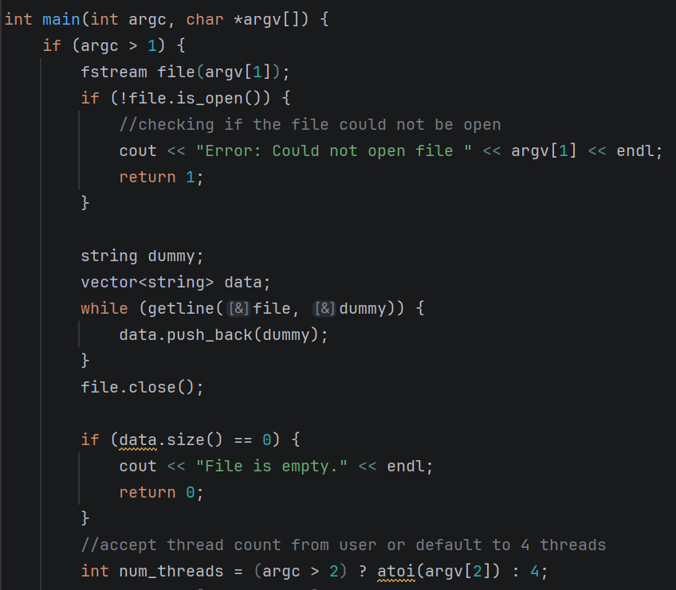

4. Thread Creation & Dispatch:
The program calculates a base chunk size by dividing the total number of lines by the thread count. A time snippet is taking to measure the effect of splitting the load over different threads.
  - A loop initializes thread_data for each thread. To ensure that all the lines are processed, the last thread is explicitly assigned all remaining lines to account for integer division truncation.
  - Threads are created and their segments are passed in the form of the thread data structure.
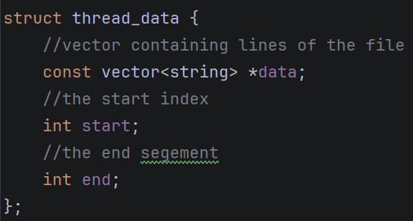

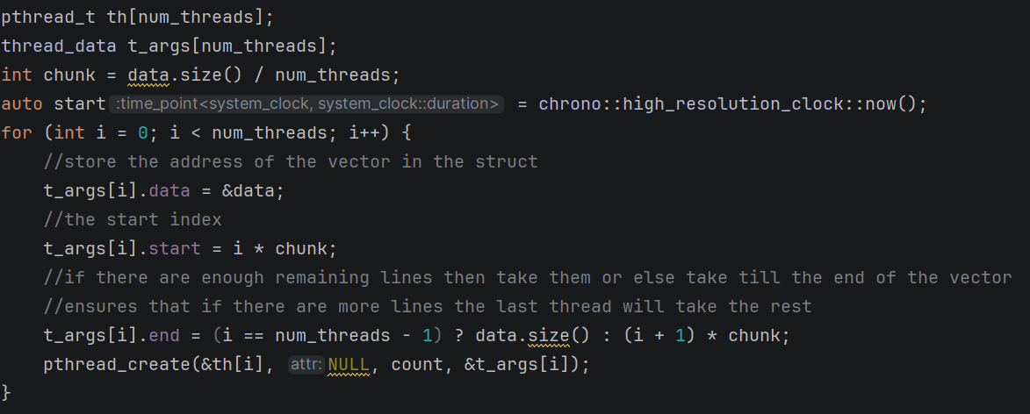
5. Synchronization: The main thread calls pthread_join() in a loop, pausing its own execution until all worker threads have completed their tasks.
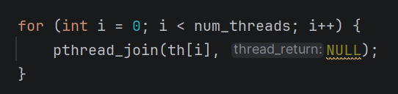
6. Local Output: The local output is printed showing the result of each thread.
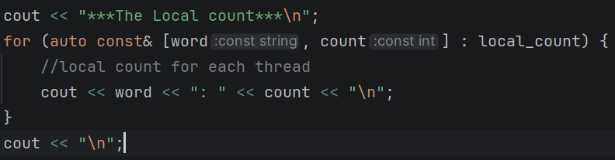
7. Output: The final aggregated word counts are printed to the console alongside the total execution time.
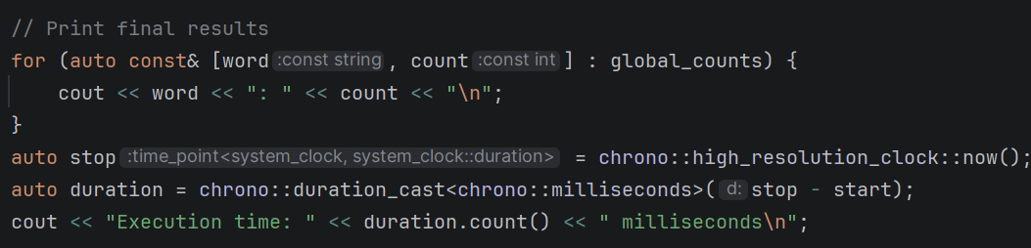

8. Performance and Concurrency Assessment
The current implementation ensures high thread safety and performance. By isolating the bulk of the computational work (string parsing, cleaning, and local counting) to thread-local variables, the program avoids creating a race condition by ensuring that each thread bulk execution is separated.
The critical section protected by a mutex lock and unlock and is kept strictly limited to the final merging of dictionaries. This ensures that the parallelized portion of the program runs at maximum efficiency.
9. Conclusion
The code implements multithreaded words count from an input text file. And the results when trying with different number of threads show a huge difference as when run with 2 threads the execution time is 130 ms. When increasing the number of threads to 20 threads, the execution time is 43 ms.
10. Github
Repo link: https://github.com/youssef1316/OS_coursework1
Commit sha: f7c6bc5713527c2ccf2e4d80fe3572e916806121

Task3
1. Introduction This report outlines the design, implementation, and analysis of a C++ program designed to simulate the Aging page replacement algorithm. The program utilizes an 8-bit counter system and reference bits to track page usage over time, efficiently managing memory frames and calculating page hits and faults for a given memory access sequence.
2. Component Analysis
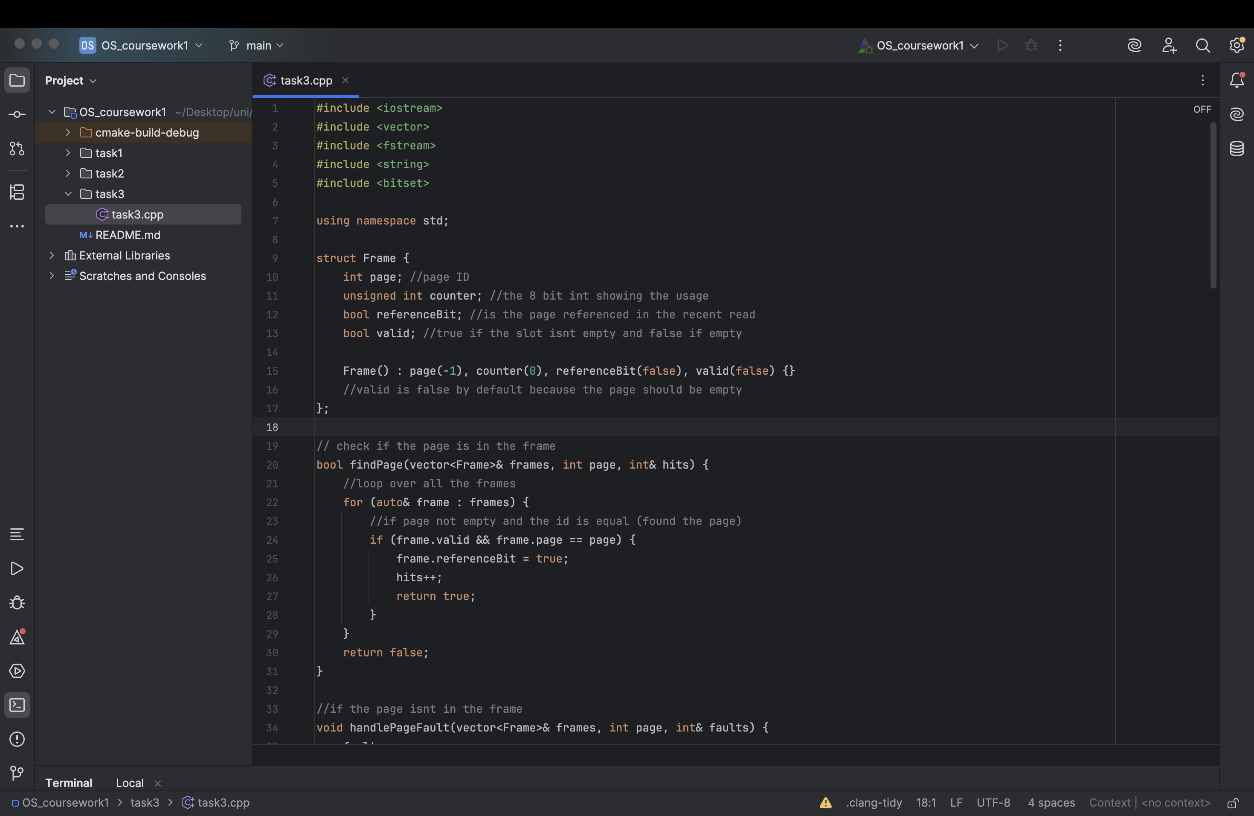
- Frame Structure: Represents an individual memory slot. It encapsulates the page ID, an integer counter for the aging process, a referenceBit indicating recent access, and a valid boolean flag to signify if the frame is currently occupied.
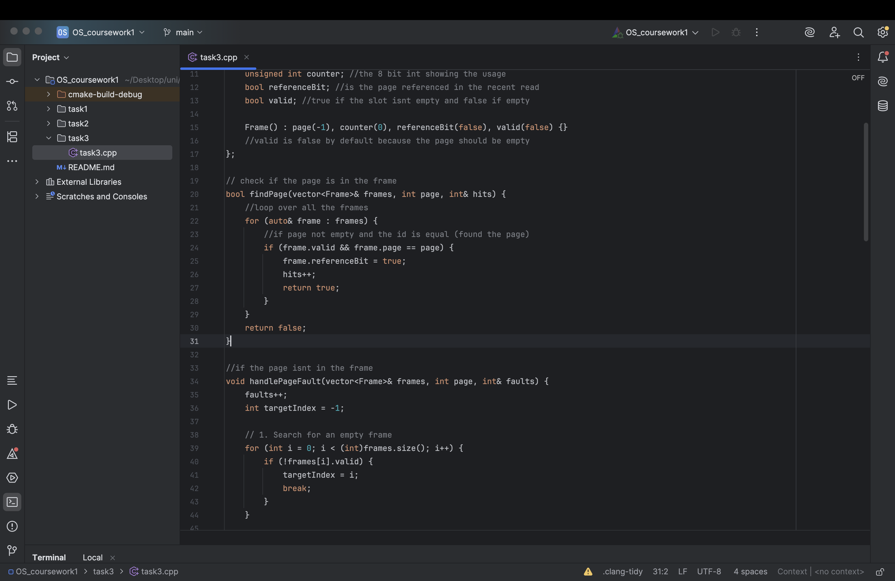
- findPage: Scans the active memory frames for a requested page. If a match is found, it updates the frame's reference bit to true, increments the hit tracker, and returns successfully.
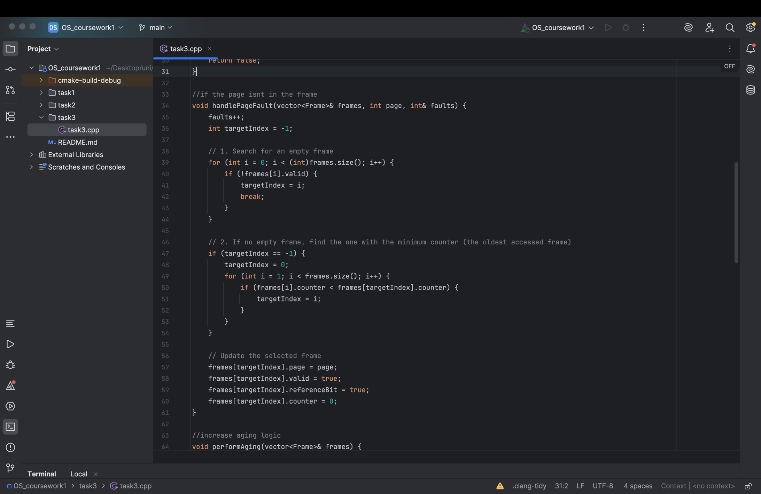
- handlePageFault: Executed when a requested page is absent from memory. It prioritizes filling empty (invalid) frames first. If all frames are occupied, it scans for the frame with the lowest counter value (representing the oldest, least frequently accessed page), evicts it, and loads the new page with an initialized counter of 0.

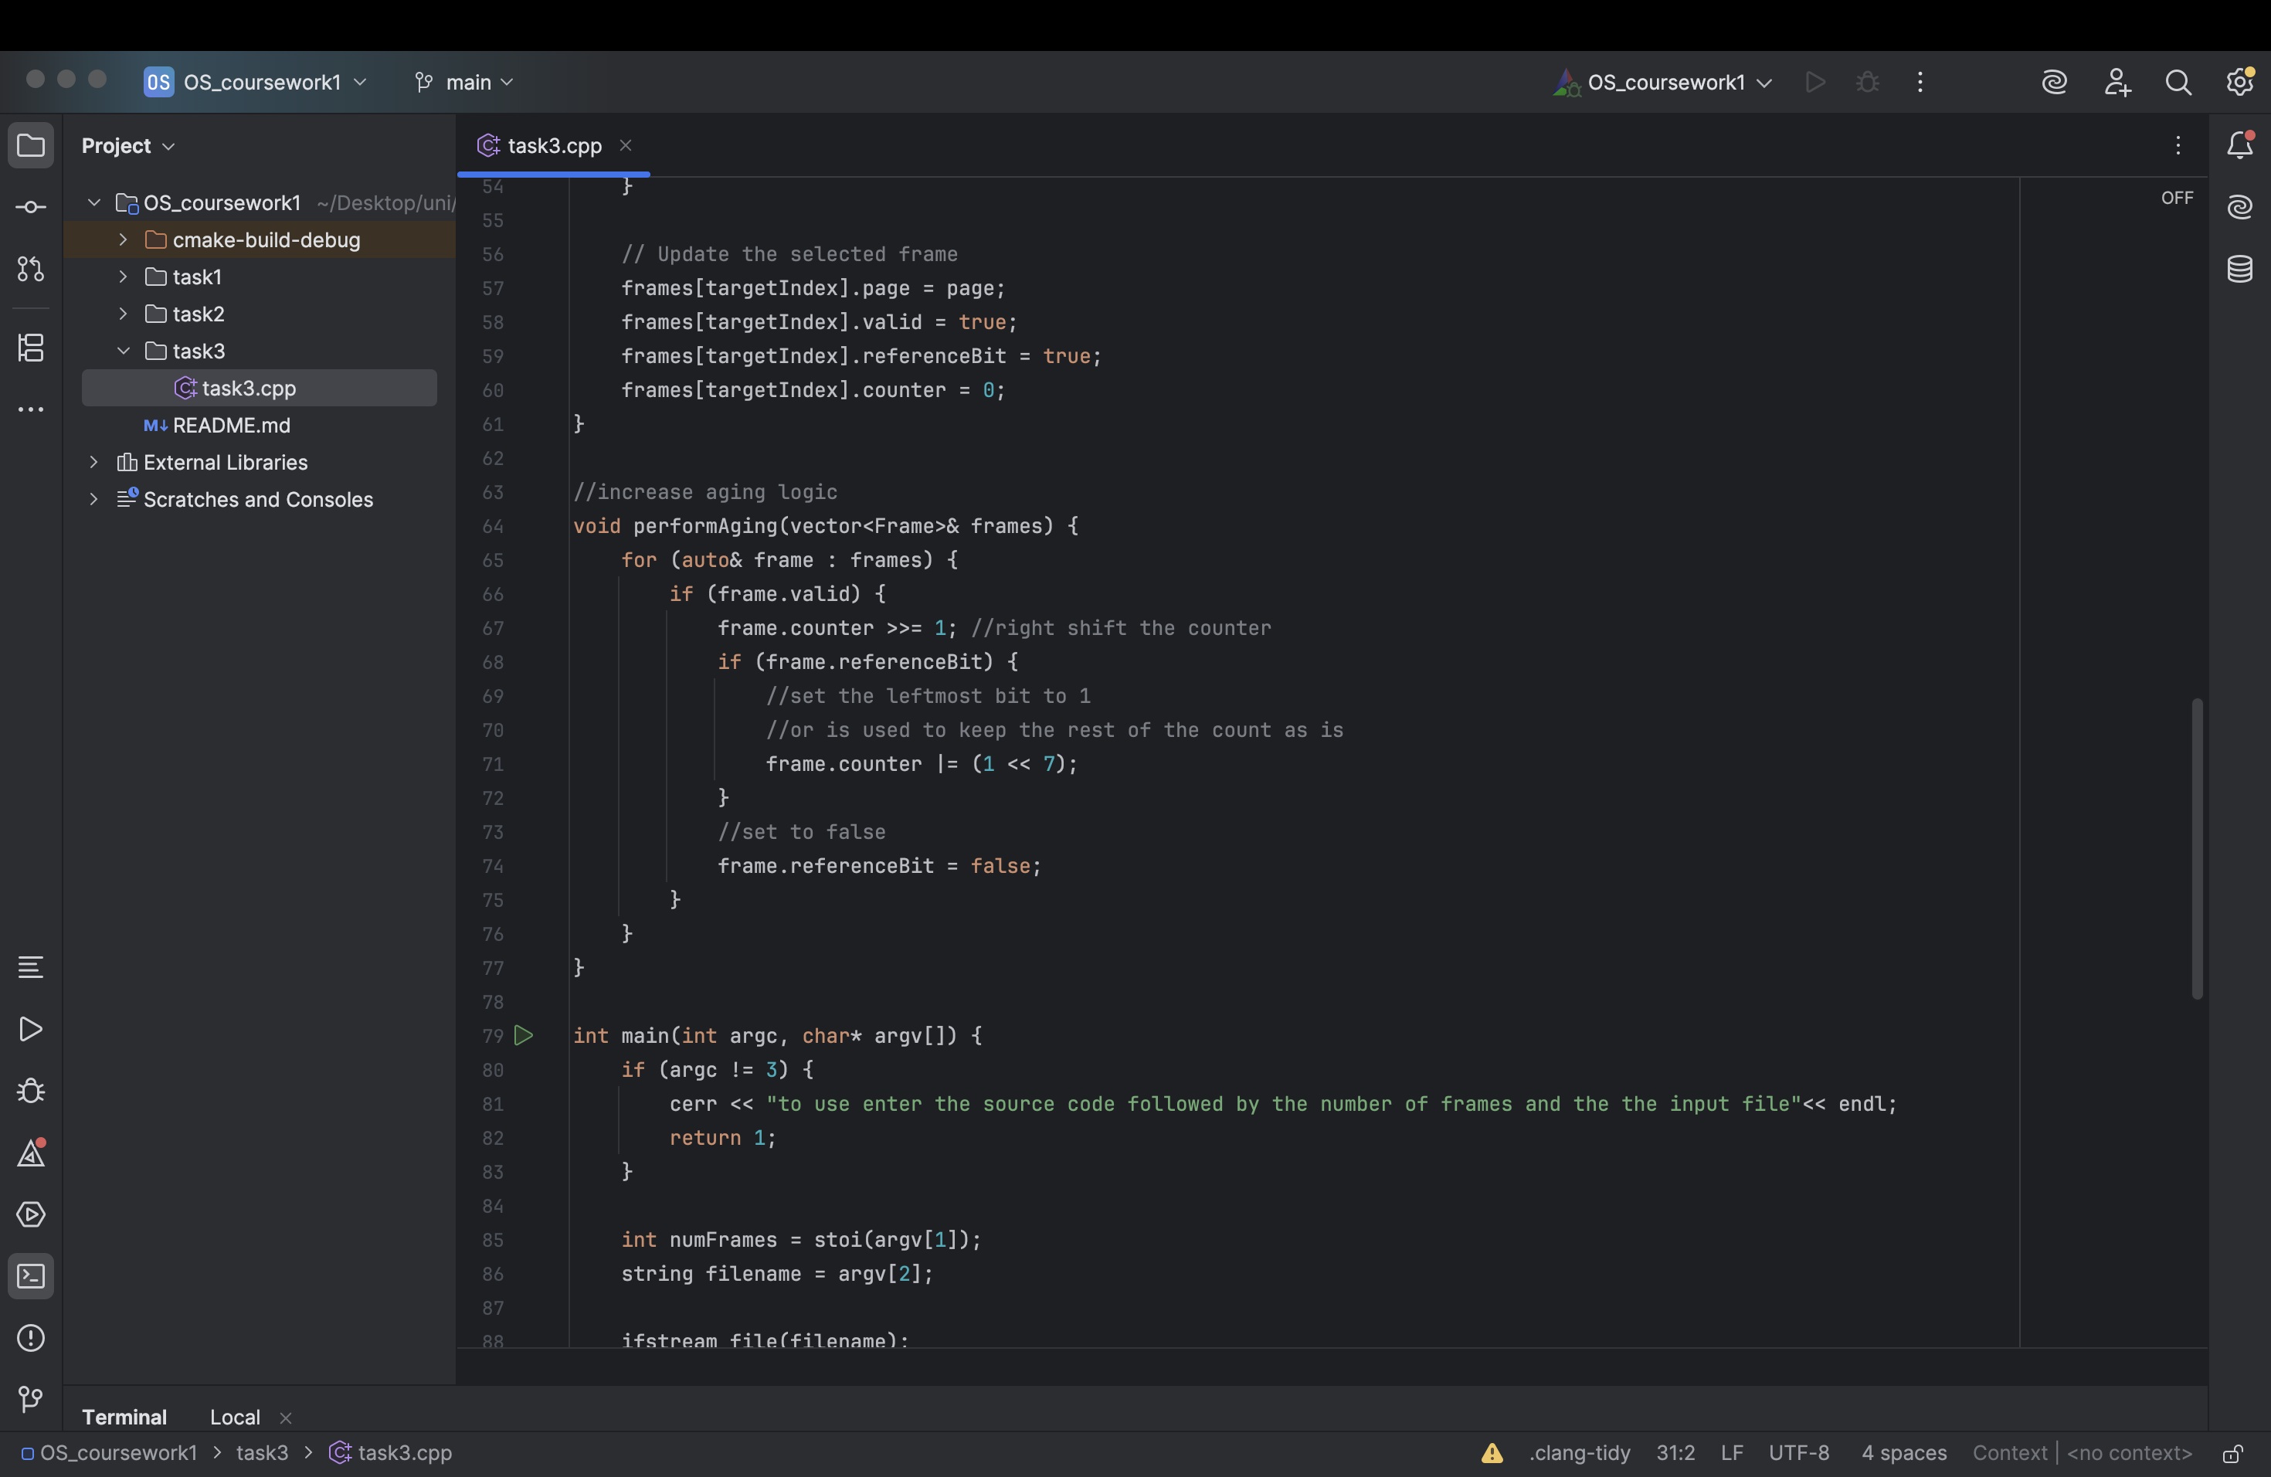
- performAging: Runs at the end of every page request cycle. It performs a bitwise right-shift (>>= 1) on the counters of all valid frames. If a frame's reference bit was triggered during the cycle, its most significant bit is set to 1 using a bitwise OR operation (|= (1 << 7)). Finally, all reference bits are reset for the next cycle.
3. Execution Flow
- Initialization: The program validates the command-line arguments, parsing the target number of memory frames and the filepath for the input data sequence.
- File I/O & Processing: The designated file is read sequentially. A continuous loop extracts requested page IDs one by one until the end of the file is reached.
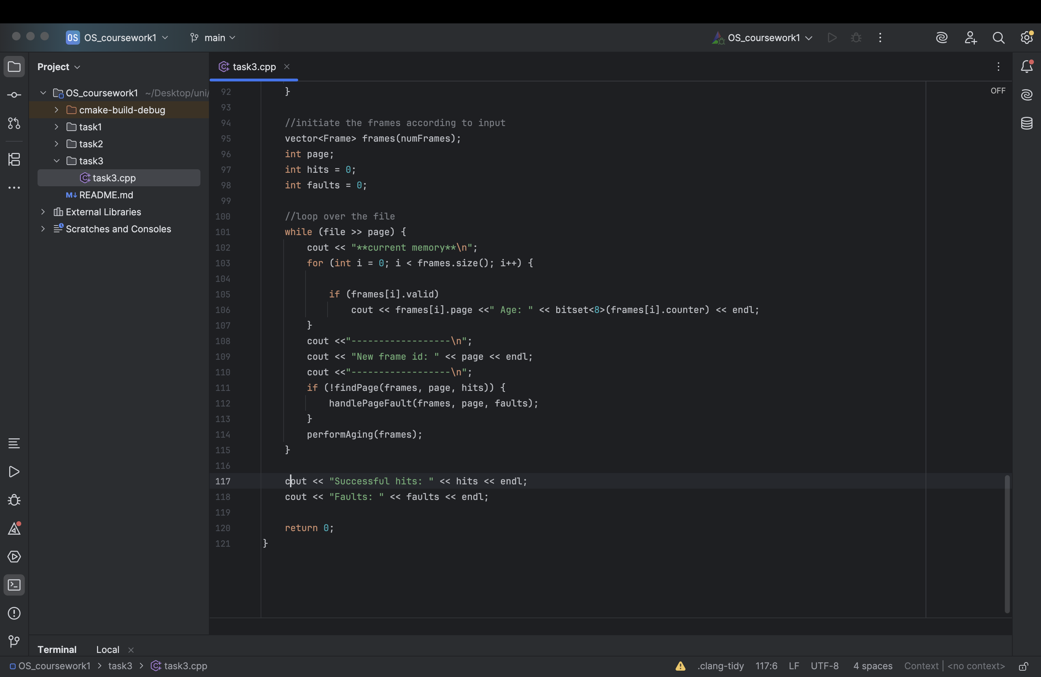
- Simulation Cycle: For each extracted page ID, the program prints the current memory state (displaying active pages and their counters in 8-bit binary). It then attempts to locate the page using findPage. If unsuccessful, it resolves the miss using handlePageFault. Following the memory access attempt, performAging updates the chronological state of all frames.
- Output: Upon processing the entire file, the final aggregated counts for successful hits and page faults are printed to the console.
4. Conclusion The code provides a functional and observable simulation of the Aging page replacement algorithm. By printing the binary state of the aging counters at each step, it offers clear insights into how the operating system evaluates memory pages and minimizes fault rates over time.
5.GitHub: repo
Commit sha: 8d1472115e03cbc92338d73b510ba2fef5b1b295

Task 4

1. Introduction
This report outlines the design, implementation, and analysis of a program designed to detect deadlocks across multiple system configurations. The program evaluates process allocations and outstanding resource requests to identify permanently blocked states.

2. Component Analysis
- Existence Vector (E): A 1D vector representing the total absolute instances of each resource type present in the system.
- Allocation Matrix (C): A 2D matrix tracking the quantity of each resource currently held by each process.
- Request Matrix (R): A 2D matrix tracking the outstanding, unfulfilled resource requests needed by each process to complete execution.
- Available Vector (A): A dynamically calculated 1D vector representing resources that are currently unallocated and free for use.
- Finish Vector (Finish): A boolean vector indicating whether a process can run to completion, initialized to true for processes holding zero resources.

3. Execution Flow
- Initialization & File I/O: The program expects the input file path as a command-line argument. It validates the argument count and opens the specified file, first reading the total number of test cases to execute.
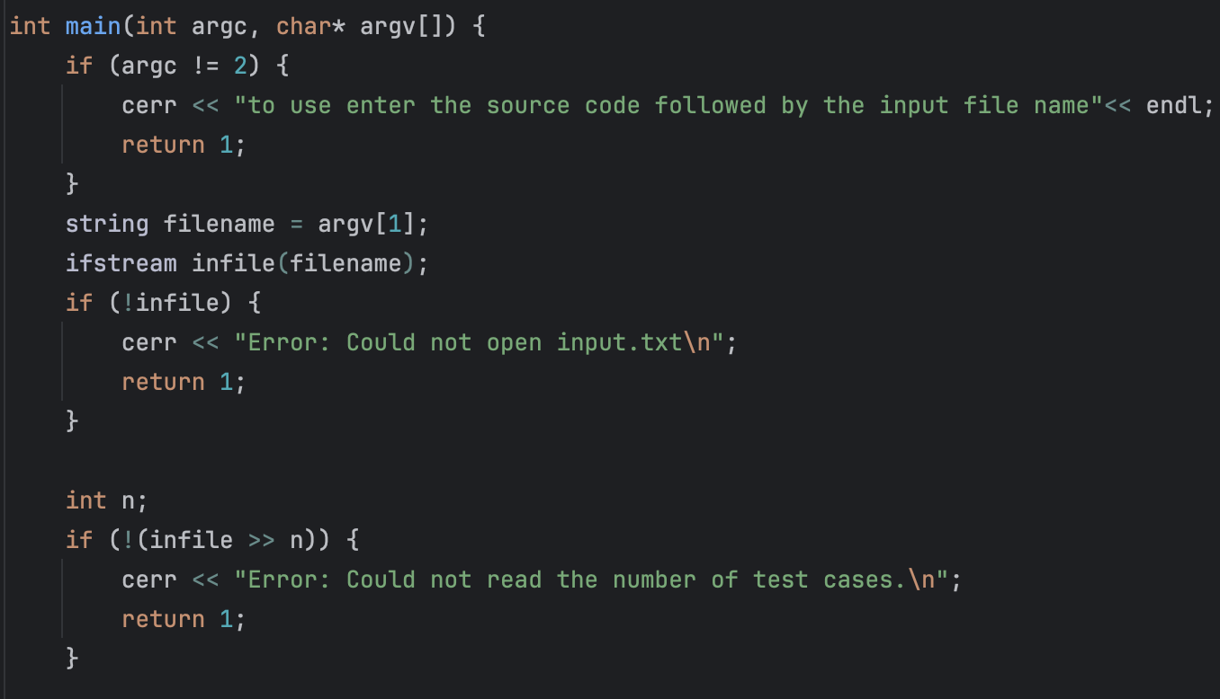
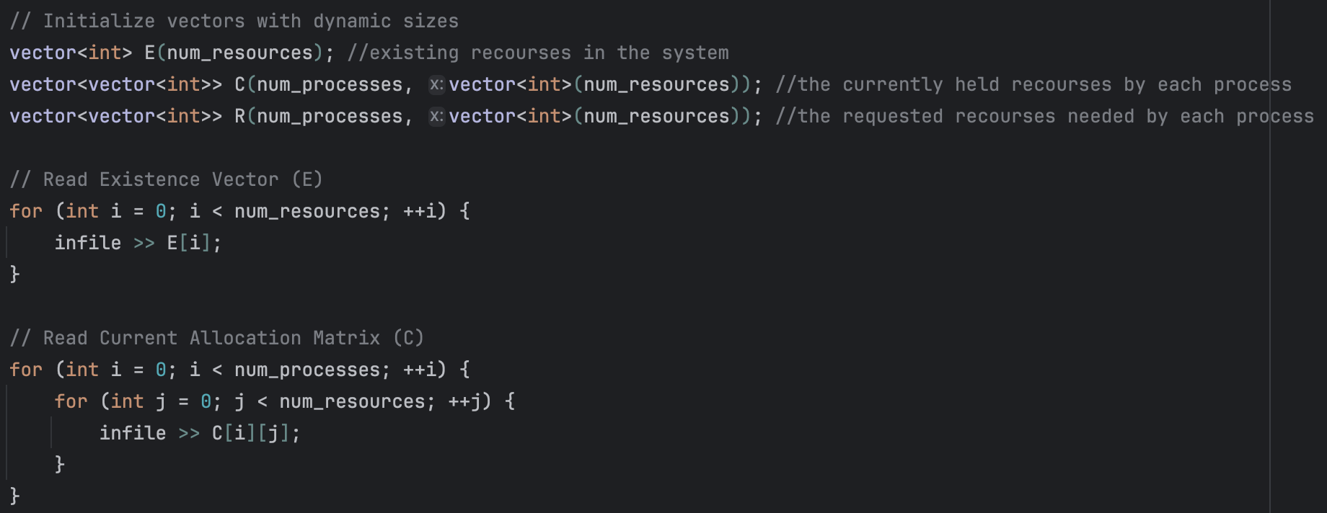
- Test Case Iteration: An outer loop processes each system scenario sequentially, re-initializing the E, C, R, and Astructures for every individual test case.
- Availability Calculation: For each scenario, the program computes the initial Available vector (A) by iterating through the Allocation Matrix (C) and subtracting all currently allocated resources from the Existence Vector (E).
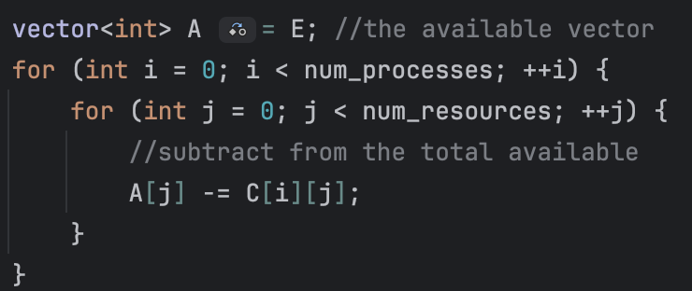
- Deadlock Detection Loop: A do-while loop continuously scans for unfinished processes.
  - State Logging: The system outputs trace messages (e.g., "Attempting to allocate for process: X") to provide real-time visibility into the algorithm's decision-making.
  - Failure Logging: If a process's pending requests (R) exceed available resources (A), the program logs the specific resource index that caused the failure, displaying the required versus available amounts.
  - Success Logging & Release: If requests are satisfied, the program simulates process completion. It logs the successful allocation, adds the currently held resources (C) back to the Available vector (A), prints the updated available resource counts, and marks the process as finished.
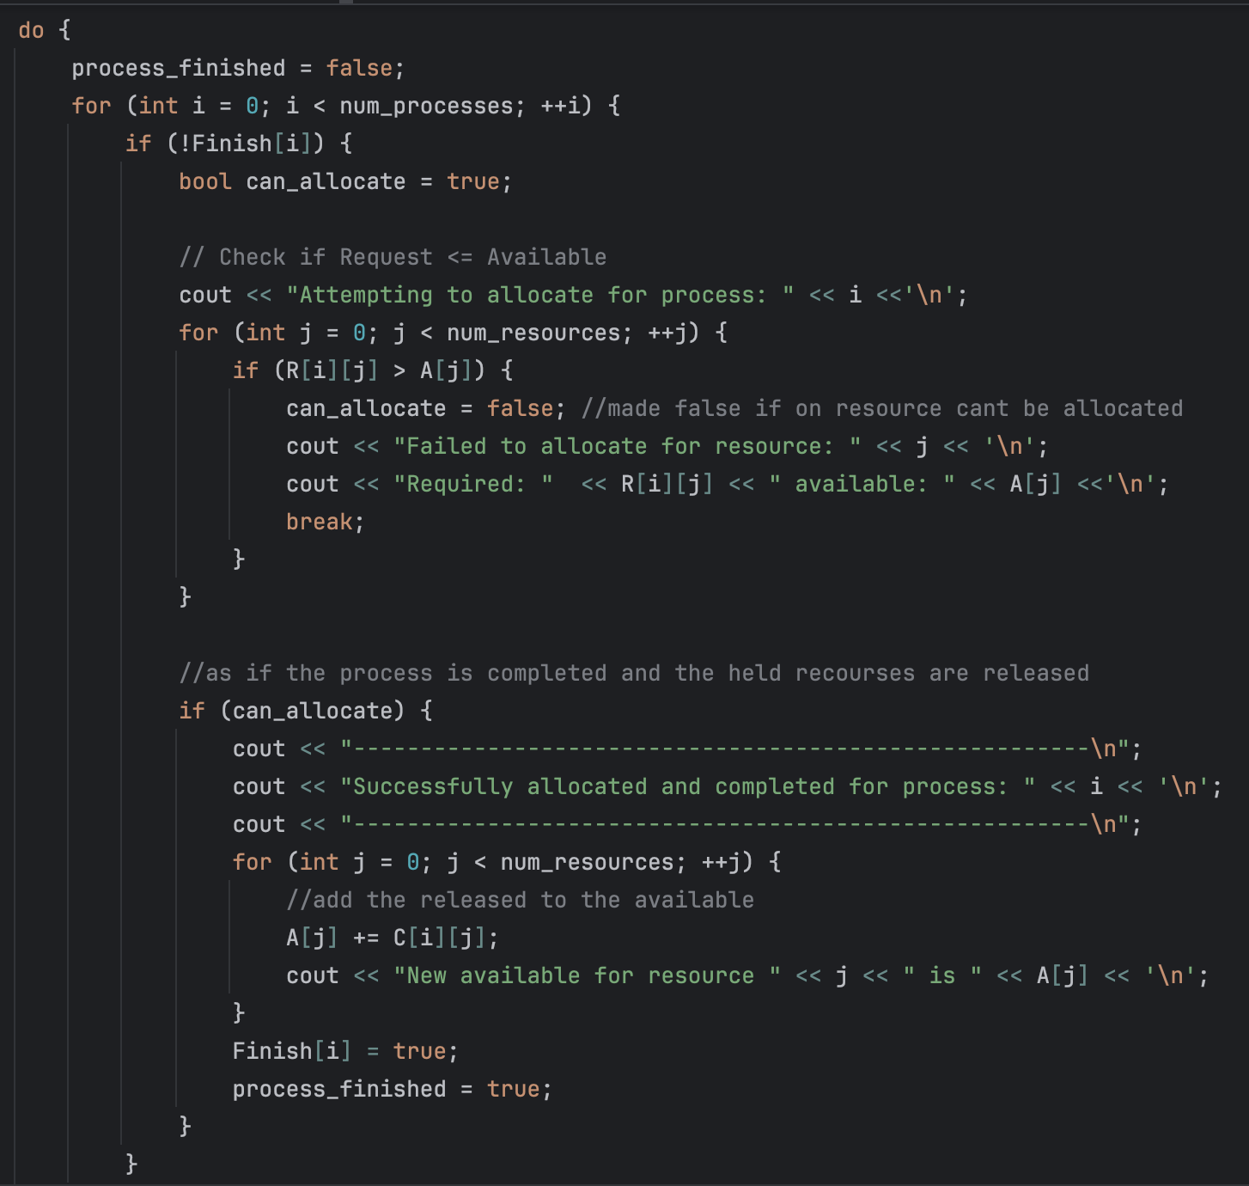

- Output Evaluation: The loop terminates when a full pass yields no new process completions. The system then evaluates the Finish vector, outputting the specific IDs of any deadlocked processes or confirming a deadlock-free state for that test case.
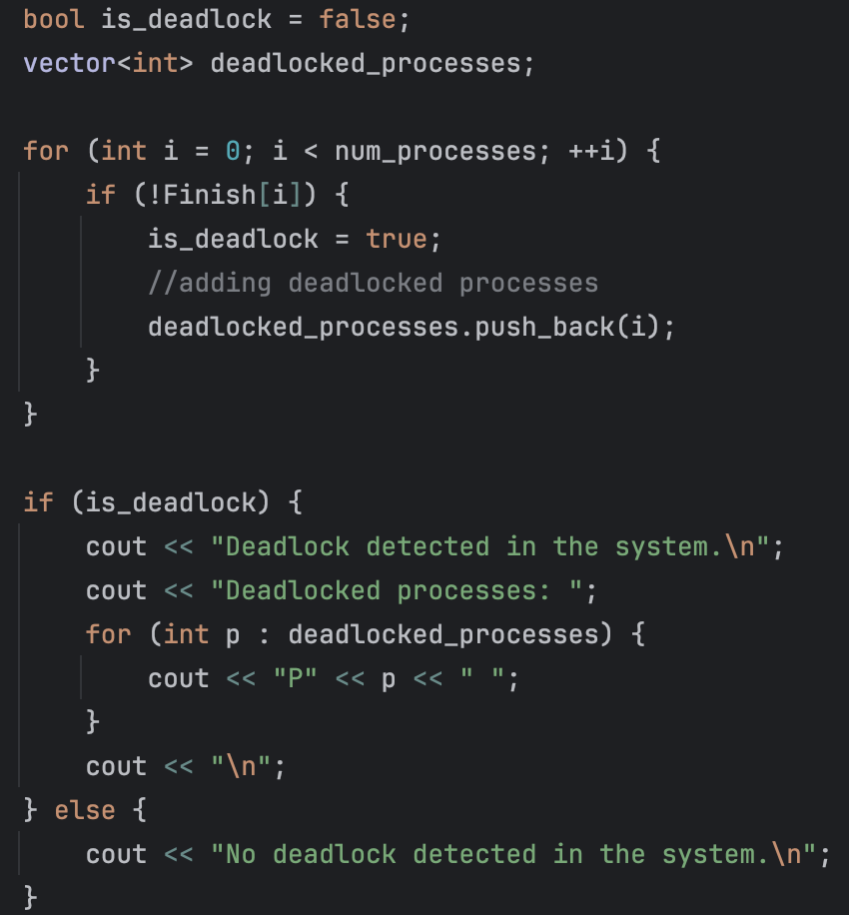

4. Conclusion
The code provides a robust and highly observable simulation of a multi-instance deadlock detection algorithm. By introducing test-case iteration and detailed console logging, it offers clear insights into the resource allocation lifecycle, allowing for precise tracking of how and why system deadlocks occur or are avoided across varying scenarios.

5.GitHub:

repo
commit sha: 621074752b4778ca677da9ac93a131009ccb55cc

Task 5

- Introduction

This report outlines the design, implementation, and analysis of a program designed to simulate CPU scheduling algorithms: First-Come, First-Served (FCFS), Shortest Job First (SJF), and Round Robin (RR). The program utilizes a process structure to track timing metrics, efficiently evaluating average wait and turnaround times for sequences of processes read from an external input file.

Component Analysis

  - Process Structure: Represents an individual CPU task. It encapsulates the process ID, initial parameters (arrival time, burst time), tracking variables for performance metrics (turn around, wait, completion time), and a remaining time variable essential for time-sliced execution.
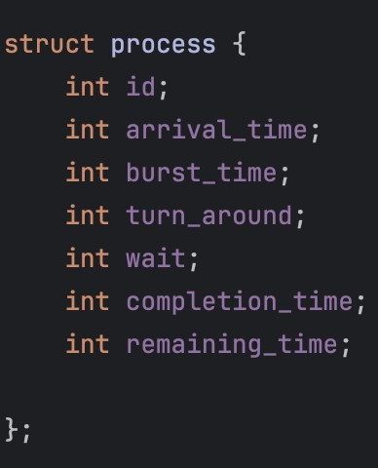
First-Come, First-Served (FCFS)

    - Mechanism: Operates on a strict non-preemptive, first-in, first-out basis. The CPU is allocated to processes in the exact order of their arrival in the ready queue. Once a process acquires the CPU, it retains control until its burst time is completely exhausted.
    - Advantages: Exhibits low implementation complexity and ensures deterministic execution.
It guarantees that every process will eventually execute, entirely eliminating the risk of process starvation.
    - Disadvantages: A single heavily CPU-bound process with a prolonged burst time will severely delay the execution of all subsequent shorter processes, drastically inflating the overall average wait and turnaround metrics of the system.
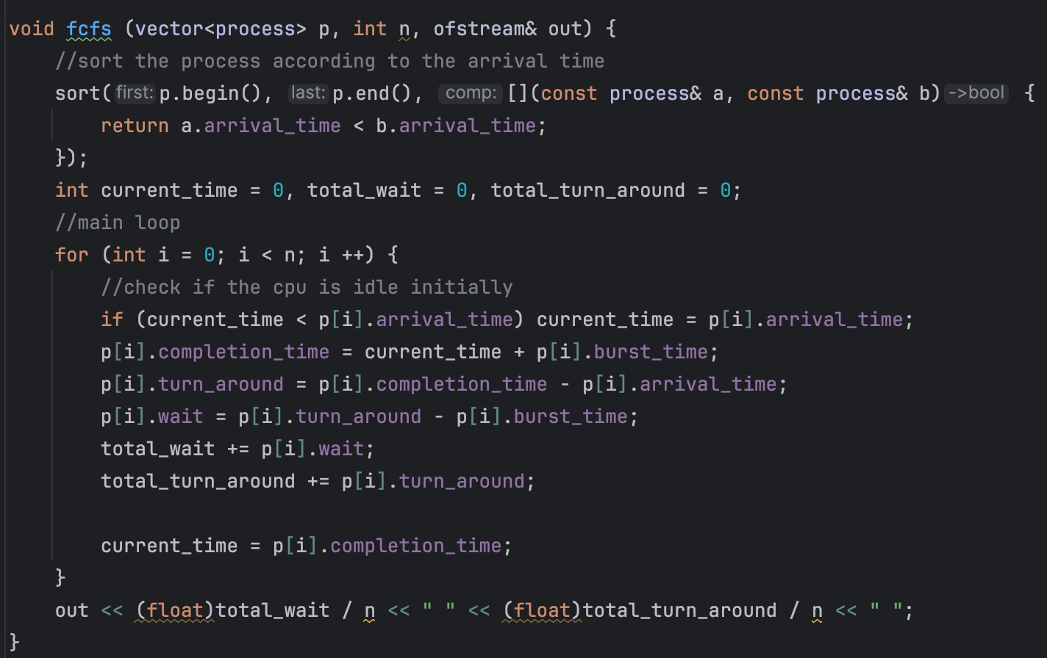
Shortest Job First (SJF) - Non-Preemptive
    - Mechanism: At each scheduling event, the algorithm evaluates the ready queue and allocates the CPU to the available process possessing the smallest total burst time. In this non-preemptive implementation, once execution commences, the process runs uninterrupted to completion, regardless of whether a shorter job arrives during its execution cycle.
    - Advantages: This algorithm is provably optimal for minimizing the average waiting time for a defined set of processes, maximizing overall system throughput.
    - Disadvantages: Introduces a significant risk of process starvation. A continuous influx of short-duration processes can continually preempt larger processes, delaying them indefinitely. Furthermore, the algorithm requires predictive knowledge of exact process execution times, a metric that is difficult to accurately forecast in live operating
environments.

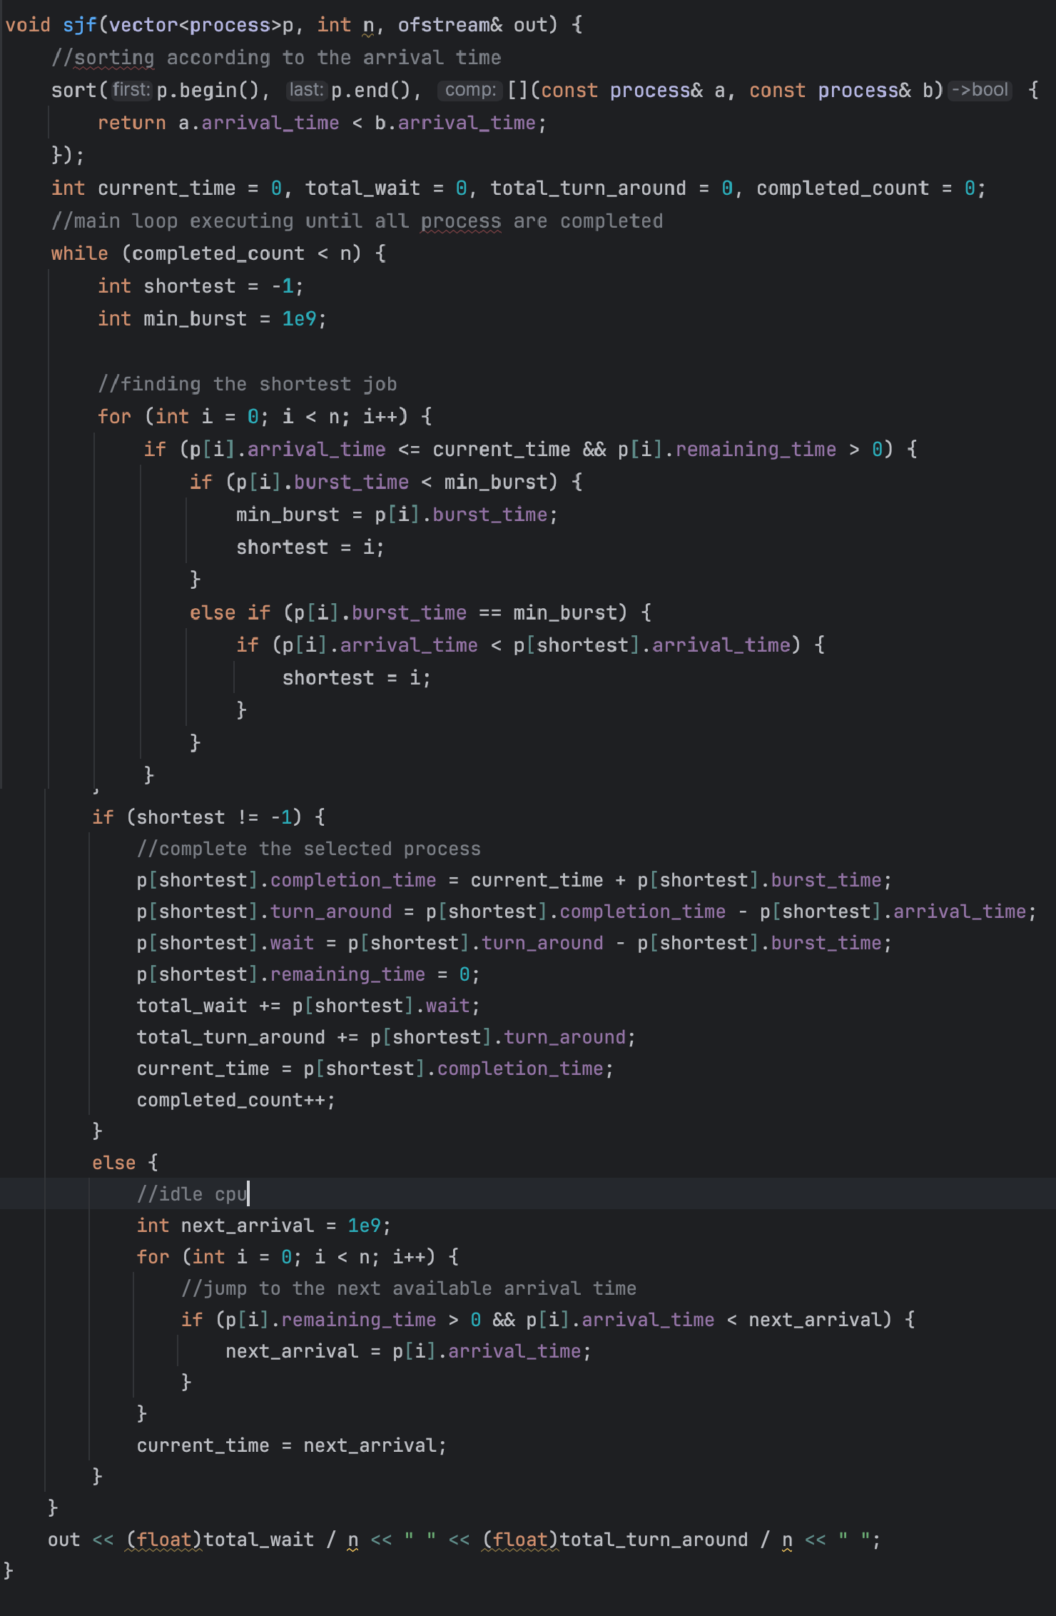

  - Round Robin (RR)

    - Mechanism: A preemptive scheduling architecture designed for multi-user responsiveness.
It assigns the CPU to each process for a strictly bound, static interval known as a time quantum. If a process does not finish within its allotted quantum, its execution is paused, and it is re-appended to the tail of the ready queue while the CPU transitions to the next pending process.
    - Advantages: Facilitates equitable CPU allocation across all active processes. It guarantees system responsiveness and prevents execution monopolies, making it the foundational scheduling logic for modern time-sharing operating systems.
Disadvantages: Algorithmic efficiency is heavily contingent on the precise configuration of the quantum size. An excessively large quantum reduces RR to standard FCFS behavior. Conversely, an overly small quantum introduces severe performance degradation, as the CPU expends disproportionate computational resources on context-switching overhead rather than active process execution.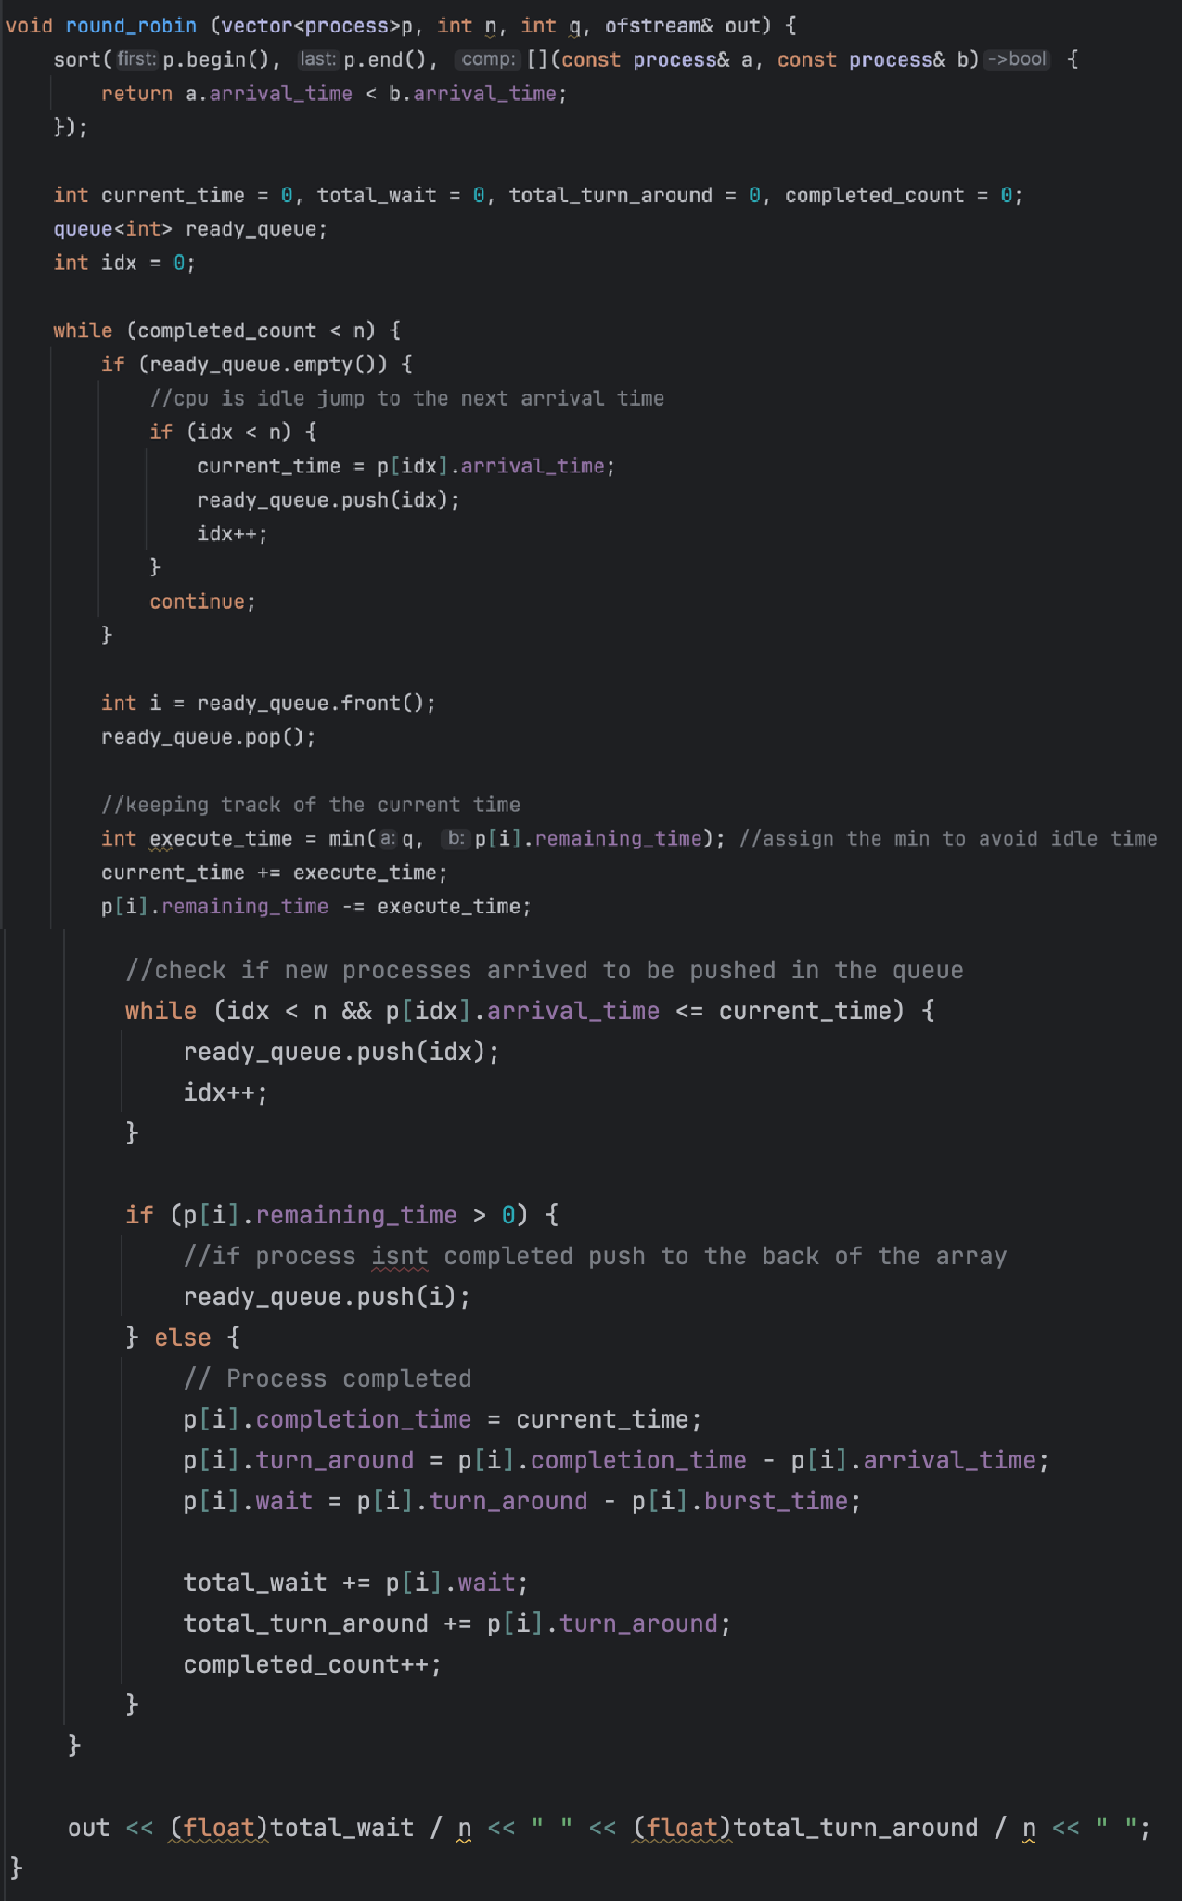

Execution Flow

Initialization: The program attempts to open "input.txt" for reading and "output.txt" for writing, halting execution if the files are inaccessible. It reads the total number of test cases to determine the execution loop duration.
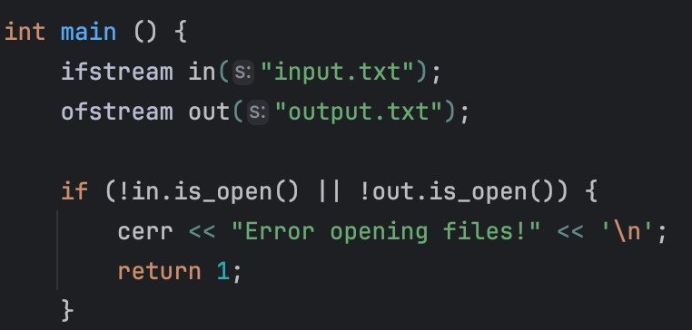

File I/O & Processing: For each test case, the program extracts the number of processes, initializes the process vectors, and sequentially populates the arrival, burst, and remaining times.
Simulation Cycle: The program passes the process vectors and the output file stream to each scheduling function consecutively. FCFS, SJF, and Round Robin (after parsing the quantum variable) process the same initial data state independent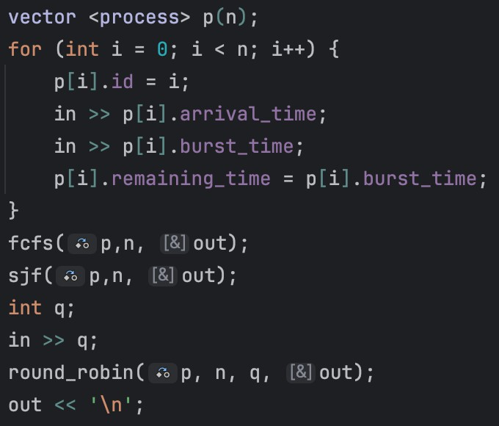

Output: Each function computes the average wait time and average turnaround time, streaming the float values directly to the output file separated by spaces. A newline is appended after each test case completes all three algorithms.

Conclusion

The code provides a functional simulation of primary CPU scheduling algorithms. By parsing bulk test cases and writing the average wait and turnaround metrics to a standardized output file, it offers an analysis and behavior of FCFS, SJF, and Round Robin systems under varying process loads.

Data Visualization

  - Script Purpose: A supplementary Python script utilizing Matplotlib and NumPy is implemented to parse the C++ output and visually represent the performance metrics.
  - Data Extraction: The script reads 'output.txt' iteratively, isolating the specific float values for average wait times and turnaround times across all three algorithms per test case.
  - Graphical Representation: It generates a unified graphical figure containing two side-by- side subplots. The script constructs grouped bar charts—color-coded by algorithm—to allow for immediate visual comparison of wait times (left subplot) and turnaround times (right subplot). Data labels are superimposed on the bars for exact metric tracking.

5. GitHub: repo

Commit sha: 7c12fc80bc9cd039b65de3eeba830a8e6be0f53d

Task 7
- Introduction This report details the architecture, underlying mechanics, and operational flow of a real-time Network Chat Application. The software relies on a multithreaded client-server model communicating over the Transmission Control Protocol (TCP) and IPv4. TCP was explicitly selected over UDP for this text-based application because it provides reliable, ordered, and error-checked delivery of a stream of bytes, ensuring that chat messages are neither lost in transit nor displayed out of sequence. The core objective of this application is to maintain simultaneous, bidirectional communication across multiple sers without frezing the user interface while waiting for network responses or keyboard input.
- Component Analysis The system is built upon several foundational operating system and memory components. File Descriptors serve as unique integer identifiers assigned by the operating system, acting as the designated "tubes" through which network data flows. The Server File Descriptor specifically acts as the main listening endpoint, while newly assigned File Descriptors (typically starting at the integer 4, as 0-2 are reserved for standard system streams and 3 is the server itself) represent individual client connections. To track these active users, the server utilizes a dynamic integer vector, functioning as a real-time roster of connected clients. Because multiple timelines of execution are reading and modifying this roster simultaneously, a Mutex (Mutual Exclusion) lock is deployed to act as a thread-safe gatekeeper, preventing catastrophic memory corruption. Finally, data transmission is facilitated by a fixed-size 1024-byte character buffer, which serves as a temporary staging area to catch raw incoming network bytes before they are processed and converted into readable text.
- Execution Flow The execution lifecycle begins with Initialization and Network Setup. Both the client and server request their primary sockets from the operating system. The server specifically configures its socket to allow immediate port reusability, a safeguard against "address already in use" errors if the application is rapidly restarted. The server then binds itself to port 8080 across all available local network interfaces and transitions into a passive listening state, establishing a backlog queue capable of holding up to three pending connections simultaneously.
Concurrently, the client translates the human-readable localhost IP address into a binary network format and initiates a TCP three-way handshake to actively connect to the server. Once the connection is established, the application enters the Concurrency and Multithreaded Session Management phase. Standard C++ executes sequentially, meaning waiting for keyboard input inherently blocks the program from reading network data. To solve this, the application branches into parallel timelines using detached threads. When the server officially accepts a client's handshake, it verifies that the total user count is below the maximum limit. It then adds the client's file descriptor to the global roster and immediately spawns a detached background thread dedicated solely to listening to that specific user. Similarly, the client application forks its execution: a detached background thread is launched to continuously listen for incoming network broadcasts, while the main thread enters an infinite loop dedicated entirely to capturing keyboard input.

The final operational phase is the Real-Time Broadcasting and Disconnect Cleanup loop. When a user types a message and presses enter, the client appends a newline delimiter and transmits the exact byte length of the string to the server. The server's dedicated listener thread catches these bytes in its temporary buffer, null-terminates the sequence to format it as a valid string, and prepares to broadcast it. Before transmitting, the server thread acquires the Mutex lock. This critical step ensures that if another user is disconnecting at that exact millisecond, the roster cannot be modified while the broadcast is occurring. The server iterates through the locked roster, sending the message to all connected clients except the original sender, and then releases the lock. If a client application is closed, the server's network read function returns a value of zero. The server responds by safely closing that specific file descriptor to free system resources, acquiring the Mutex lock once more, and permanently erasing the disconnected user from the active roster.
- Conclusion This application successfully demonstrates the practical implementation of low-level POSIX networking, parallel processing, and thread-safe memory management. By offloading blocking input/output operations to detached background threads and strictly regulating shared memory access with mutex locks, the system guarantees a secure, highly responsive, and non-blocking environment. It provides a highly observable model for understanding how operating systems route real-time data and manage the complex lifecycles of concurrent network connections.
- GitHub repo sha: f2798220a75a7b3fb11c7a4d114ac883035e3f62

